Nama : Rizqi Surowati

Kelas : 5C

Nim : 18090072

**Source Code**

1. view-form-matakuliah.php : application/views
2. Matakuliah.php : application/controllers
3. v_header.php : application/views
4. v_footer.php : application/views
5. v_index.php : application/views
6. web.php : application/controllers

**Url**

Matakuliah.php :

[http://localhost/pustaka_booking_sr/index.php/matakuliah](http://localhost/pustaka_booking_berlian/index.php/matakuliah)

**Capture Hasil**

1. matakuliah.php

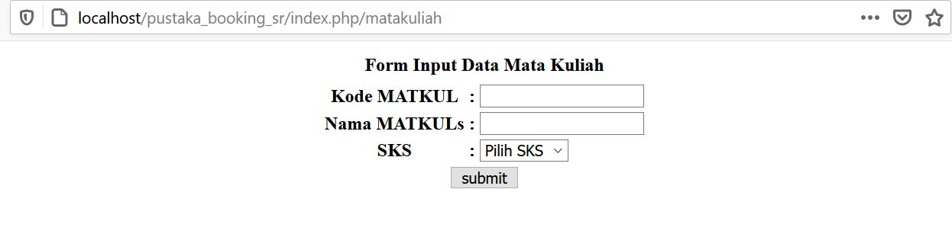

**Url**

web.php :

<http://localhost/pustaka_booking_sr/index.php/web>

**Capture Hasil**

1. web.php

